Mod 7 HW

Mason Deja

6/28/17

Chemical waste disposal

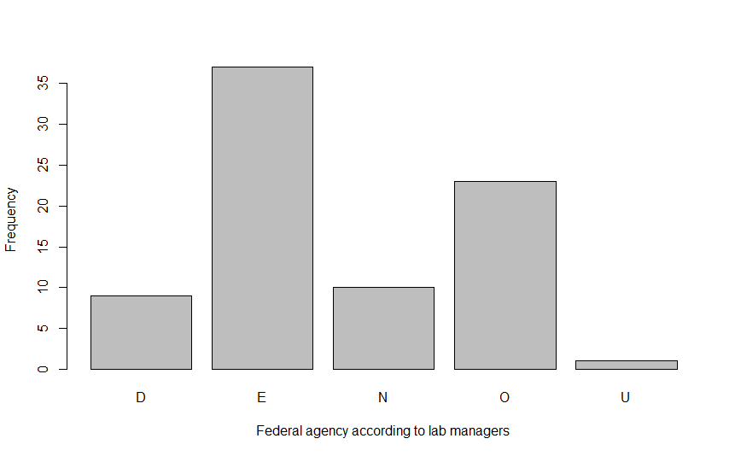

Figure 1. Barplot of which agencies lab managers then disposed of chemical waste (D=Department of Transportation, E=Environmental Protection Agency, XXXXXXX).

Drawing a conclusion from this data set shows that the majority of lab managers think that Environmental Protection Agency is where chemical waste disposal takes place followed by Occupational safety and health administration, then by national institutes of health, then department of transportation and finally by unanswered (Figure 1).

Water usage

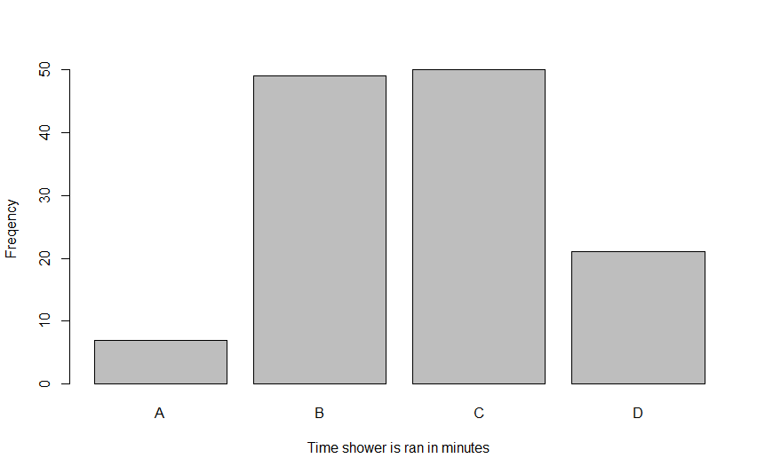

Figure 2. Water usage levels of students at Rice University (A=0-5 minutes, B=6-10 minutes, C=11-15 minutes and D= over 15 minutes).

In this bar plot we can conclude that the majority of people let the shower run for 11-15 minutes, which was followed closely by 6-10 minutes, then by over 15 minutes and then by 0-5 minutes (Figure 2).

R code

Chemical waste

library(NCStats)

setwd("~/R stuff")

dfobj<-read.csv("chemicalwastedisposal.csv")

str(dfobj)

headtail(dfobj)

( tbl.agency<- xtabs(~agency,data=dfobj))

percTable(tbl.agency,digits=3)

barplot(tbl.agency,xlab = "Federal agency according to lab managers", ylab = "Frequency")

Water usage

library(NCStats)

setwd("~/R stuff")

df<-read.csv("WaterUsage.csv")

str(df)

headtail(df)

( tbl.minutes<- xtabs(~water.usage,data=df))

percTable(tbl.minutes,digits=3)

barplot(tbl.minutes,xlab = "Time shower is ran in minutes", ylab ="Freqency")